Stage 3 – "I’d buy that for a dollar"
COURSE DESIGNER: Billy Barton (Spectrain)
SCORING: Comstock 28 rounds.
TARGETS: 13 cardboard targets, 2 steel targets.
SCORED HITS: 2 Best hits per carboard will be scored.

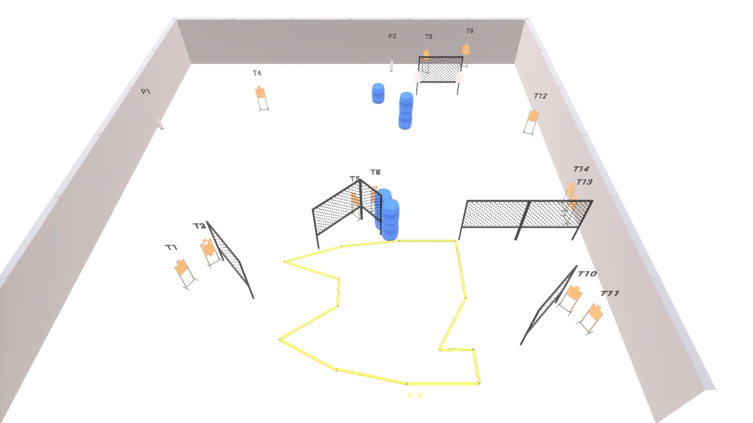

Written Stage Briefing:

Stage 3 – "I’d buy that for a dollar" - is a 28 round, 140 point, Comstock Course. There are 13 cardboard targets and 2 steel targets.

Starting with both feet on the Shooting Sports Innovations Xs
Handgun is loaded and holstered, wrists below belt.
PCC is loaded held in both hands, stock on belt.

On the audible start signal, engage targets from within the shooting area.

USPSA / NROI Range Commands:
- Make Ready
- Are you ready?
- Standby
- If finished, unload and show clear
- If clear, hammer down and holster (Handgun)
If clear, hammer down and flag (PCC)
If clear, cylinder closed and holster (Revolver)
- Range is clear

Setup Notes:
10 Single Wall Stands
2 Double Wall Stands
6 Full Walls
1 Half Wall
13 Target stands / 26 target sticks
2 small popper + base
8+ Barrels



